The Younger Me Is Watching, And She Has Notes
By: Lana Nycole
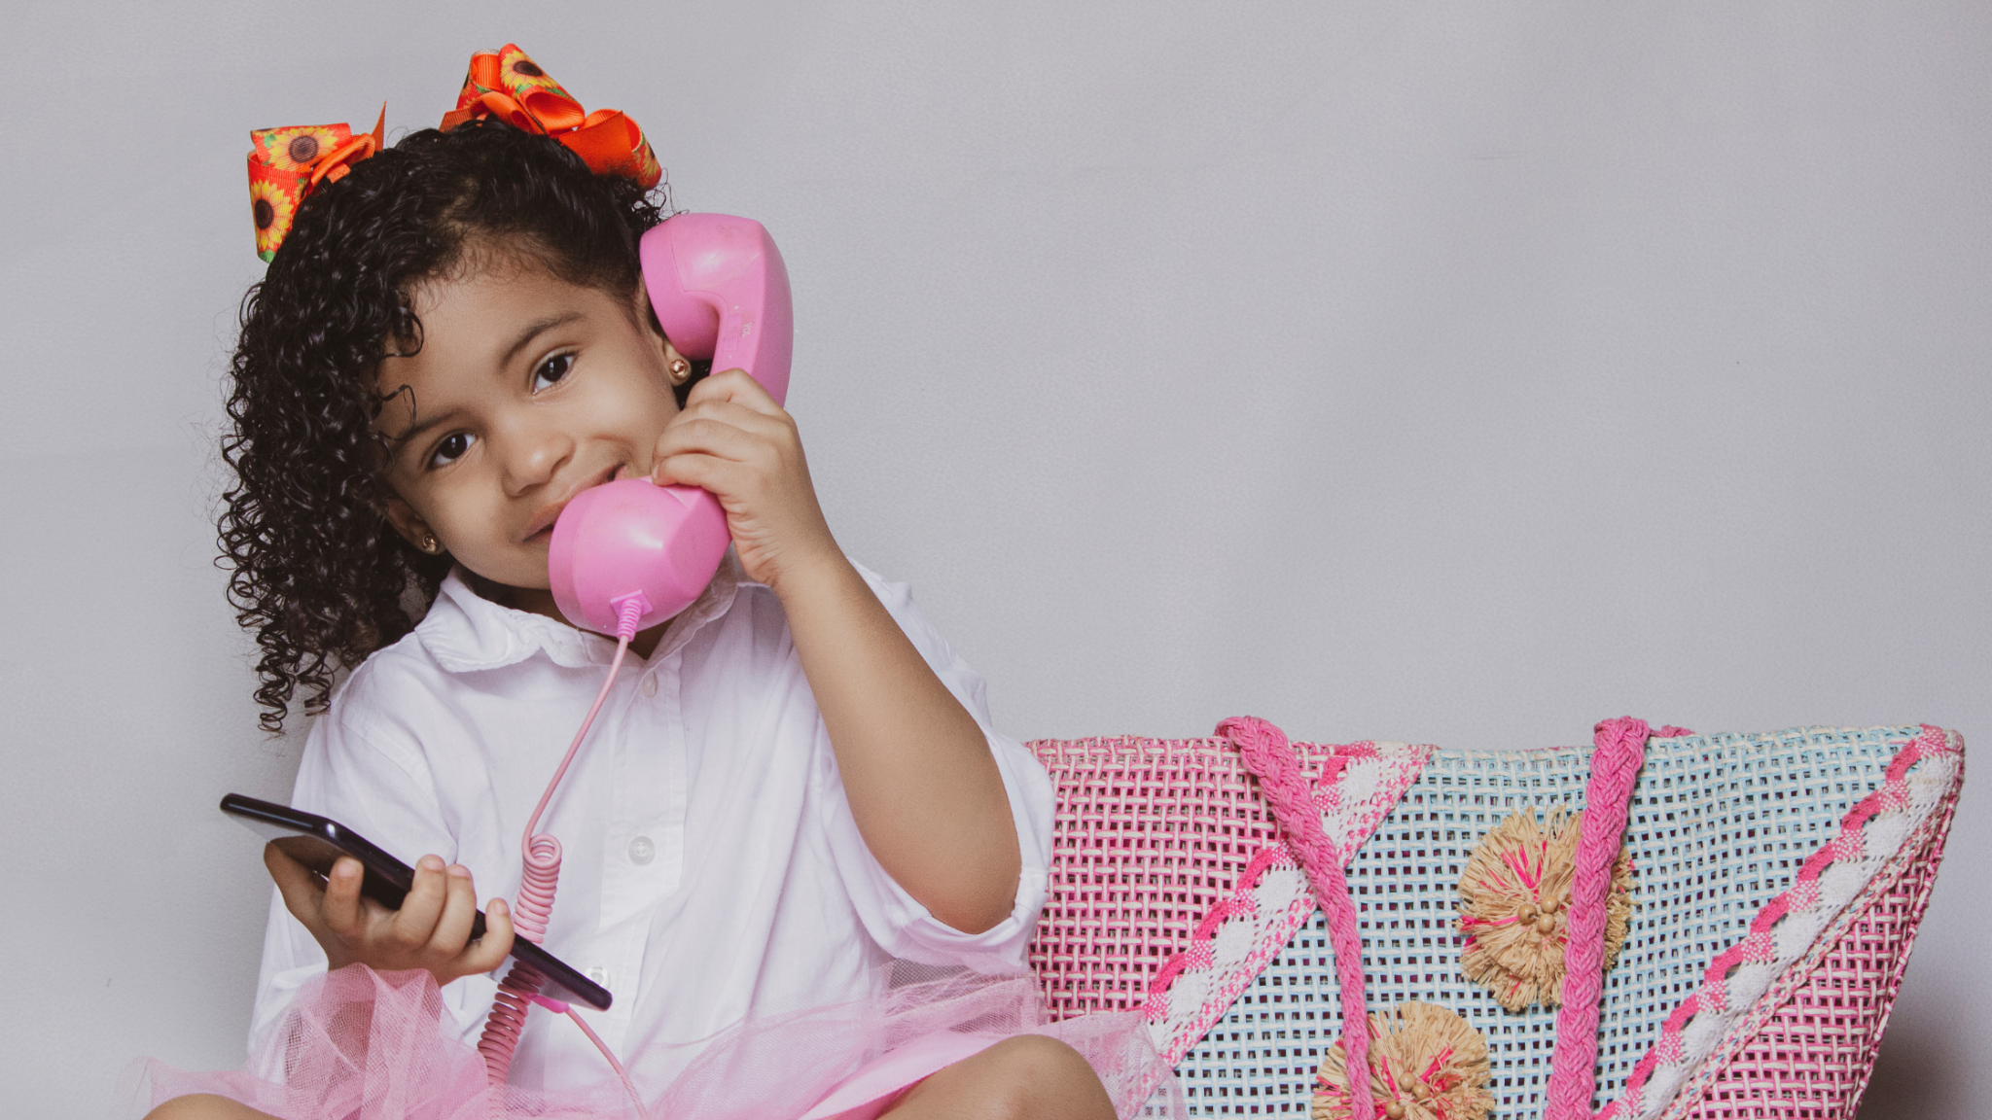
There’s something about summer that always stirs up the spirit of my younger self. Maybe it’s the long days begging me to play hooky. Maybe it’s the fact that the '90s are back with a vengeance and I’m having flashbacks. But to me, the world feels alive with nostalgia right now. And that reminds me that joy doesn’t have to be earned. It can be as simple as eating ice cream before dinner just because you can. Or inviting your friends over for a sleepover so that the girl talk doesn’t have to end.
Lately, I've been trying to make more space for the version of me that still longs to do these things. The girl who believed in magic. Who wasn’t worried about being productive or impressive or carrying the weight of her trauma. She just wanted to dance when her song came on.
So, I’ve started inviting her in.
Over the last few weeks, I’ve made a habit of sitting down without my phone or a to-do list, just a pen and a journal.
I ask, What do you want? What do you need? What would make today feel like the best day ever?
She told me to get dressed up. She told me to wear glitter. She said she missed the days when I used my hairbrush as a microphone more than a hairbrush.
And then she asked me, When did we stop believing in the power of our imagination?
That question stuck with me. It reminded me of one I often ask new friends: What would your younger self think of you and your life today? It always reveals something tender, something raw, something real. Because the truth is, most of us are still carrying pieces of that younger self, whether we realize it or not. And often, she’s still hoping we’ll slow down long enough to hear her out.
The artist, teacher, and author SARK has one of my all-time favorite quotes,
“The opposite of old is not young. The opposite of old is new. As long as we continue to experience the new, we will gloriously inhabit all of the ages that we are.”
And maybe that’s what summer gives us, a window into those new, old parts of ourselves. The ones that never stopped dreaming, dancing, or pretending. The ones that still live inside us, just waiting to be engaged.
So this season, wear the glitter. Sing into the hairbrush. Let your joy be silly, sacred, and free.
She’s still here,and she’s ready to thrive.

Let &Rise help you get in touch with your inner child
It’s easy to lose touch with your inner child as you get older and the responsibilities of adult life take up more of your time. If you’ve experienced trauma, your inner child may be busy looking out for threats and trying to protect you. Creating a sense of safety she can really feel and getting her to come out and play are important parts of the healing process.

At &Rise, we create plenty of opportunities for our members to let their little selves breathe. We’ve done inner child journaling workshops, somatic experiencing, sound baths, and other self-pampering events. Take a look at our Events page to see what’s coming up.

Want to stay in the loop on &Rise events and get a nugget of self-care inspiration in your inbox every week? Subscribe to our newsletter today.

